AI ASSIGNMENT-17.4
Task 1 – Employee Data Preprocessing
Task:
Use AI to generate a Python script for cleaning an employee dataset.
Instructions:
• Handle missing values in columns (salary, department,
joining_date).
• Convert the "joining_date" column into proper datetime format.
• Standardize department names (e.g., "HR", "hr", "Human
Resources" → "HR").
• Encode categorical variables (department, job_role).
Expected Output:
• A cleaned Pandas DataFrame with consistent departments, proper
dates, and encoded features.
PROMPT: 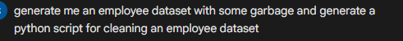
CODE:
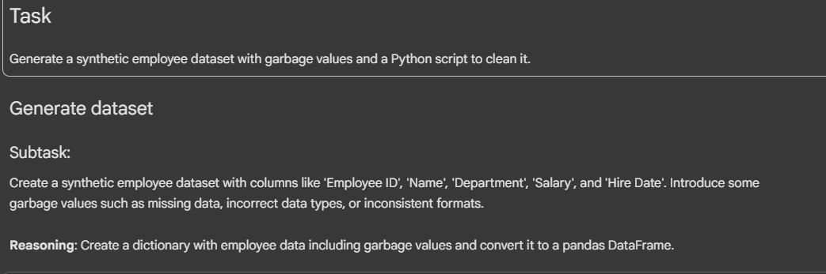
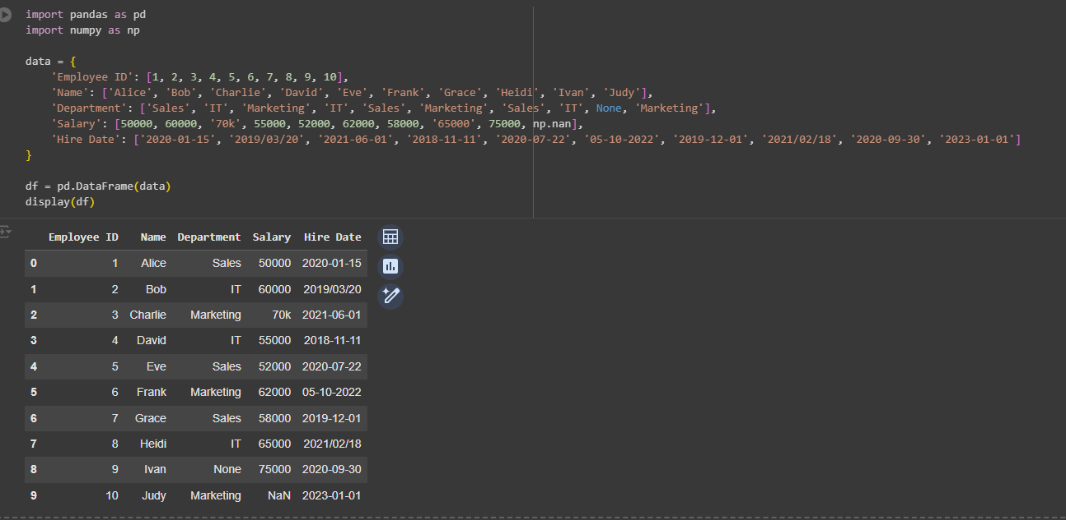
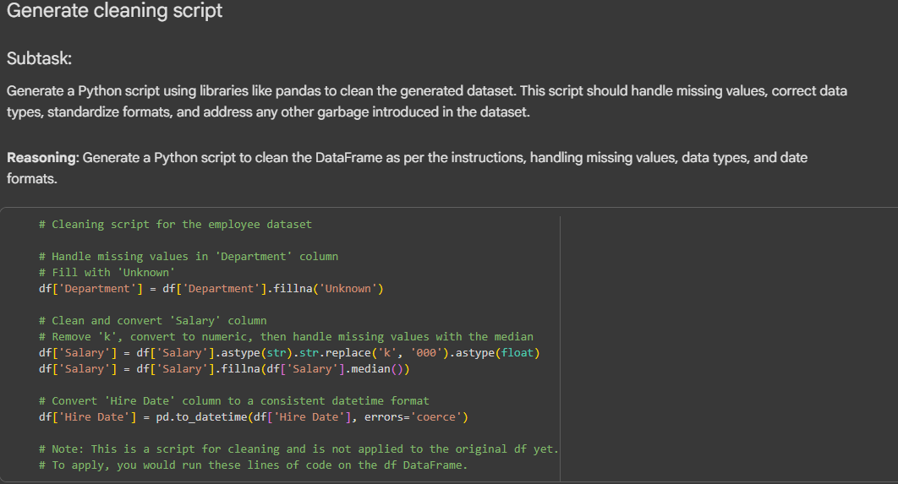
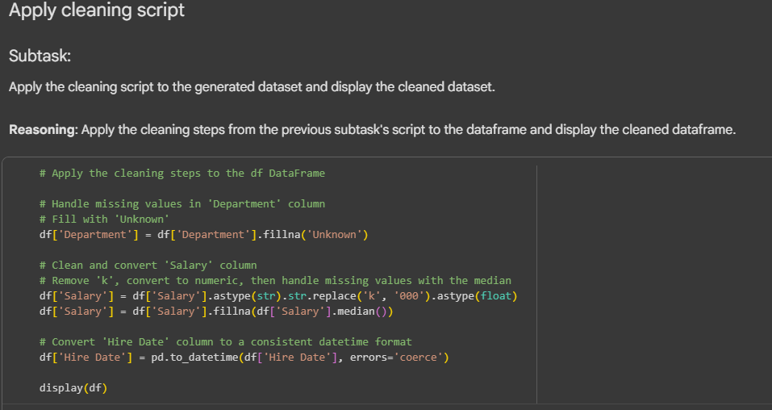
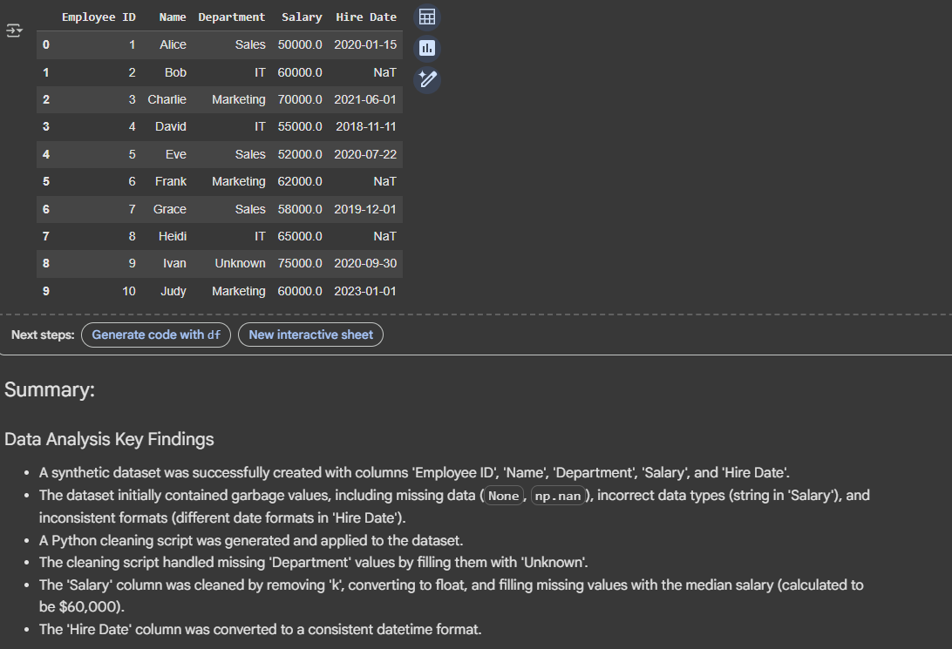
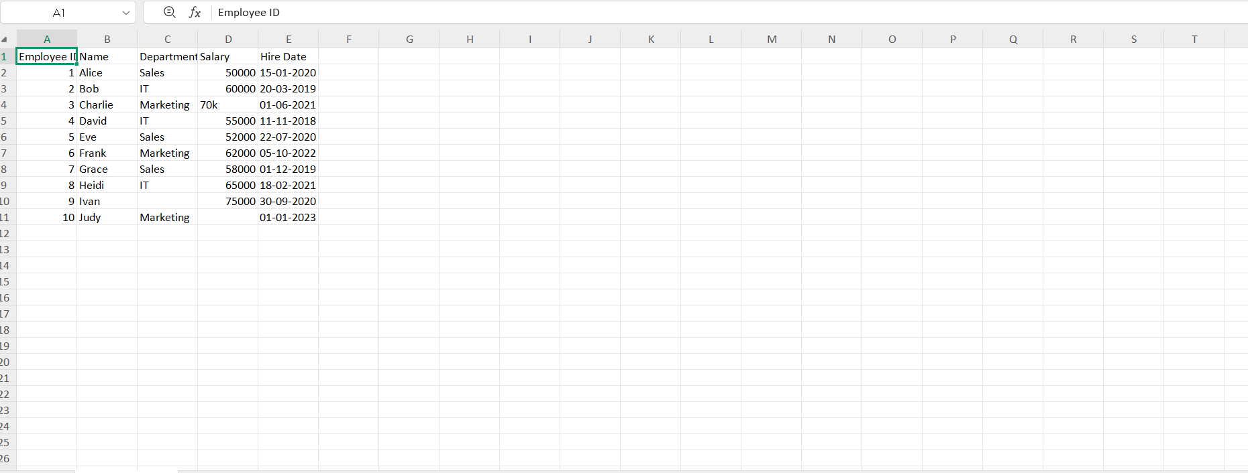
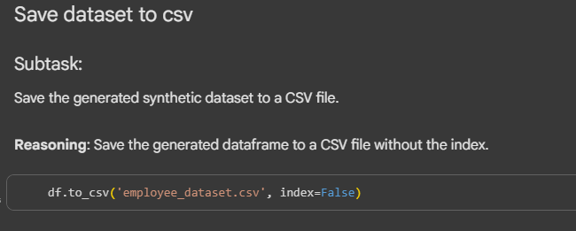
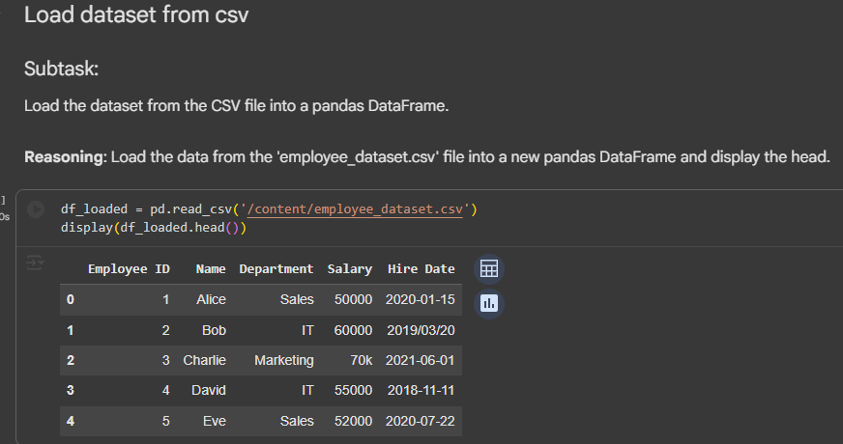
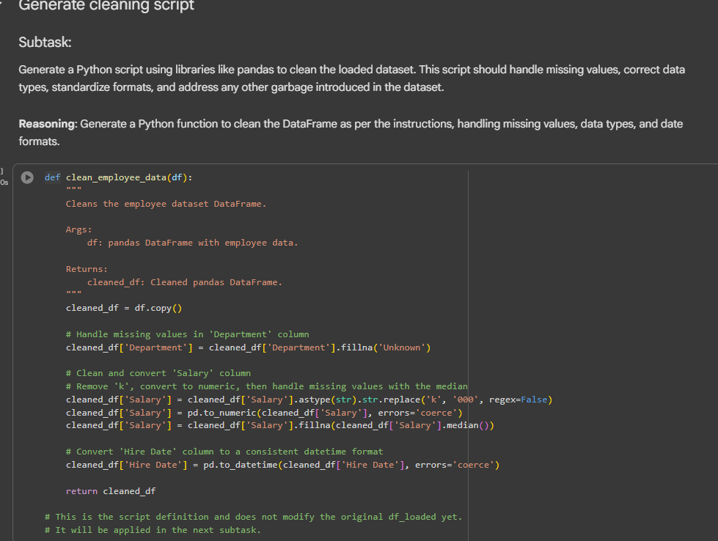
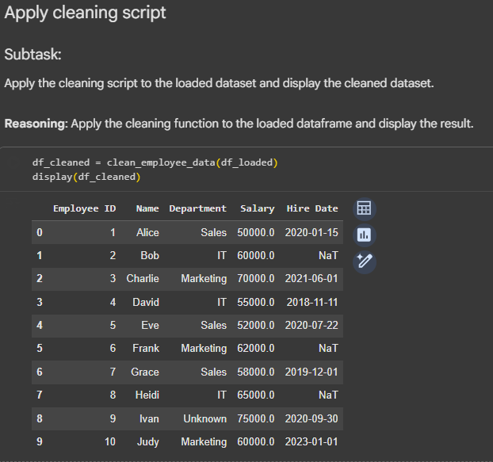

Task 2 – Sales Transaction Data Preprocessing
Task:
Use AI to generate a script for preprocessing a sales transaction dataset.
Instructions:
• Convert transaction dates to proper datetime format.
• Create a new column for “Month-Year” from the transaction date.
• Remove rows with negative or zero transaction amounts.
• Normalize the "transaction_amount" column using Min-Max
scaling.
Expected Output:
• A preprocessed DataFrame with valid dates, normalized amounts,
and no invalid records.

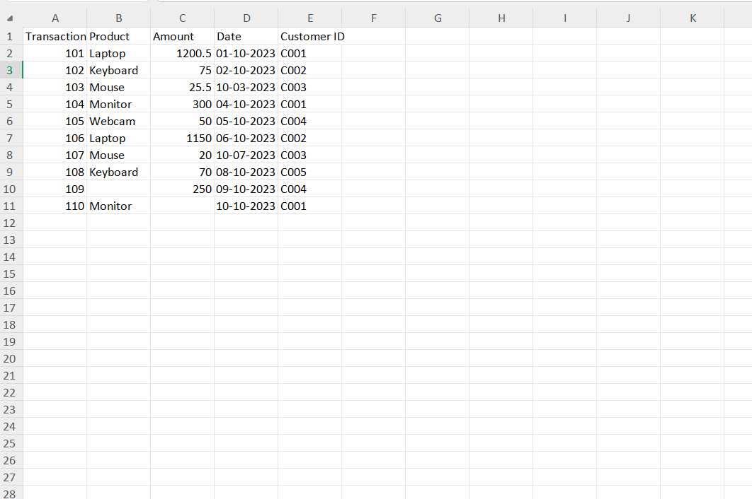
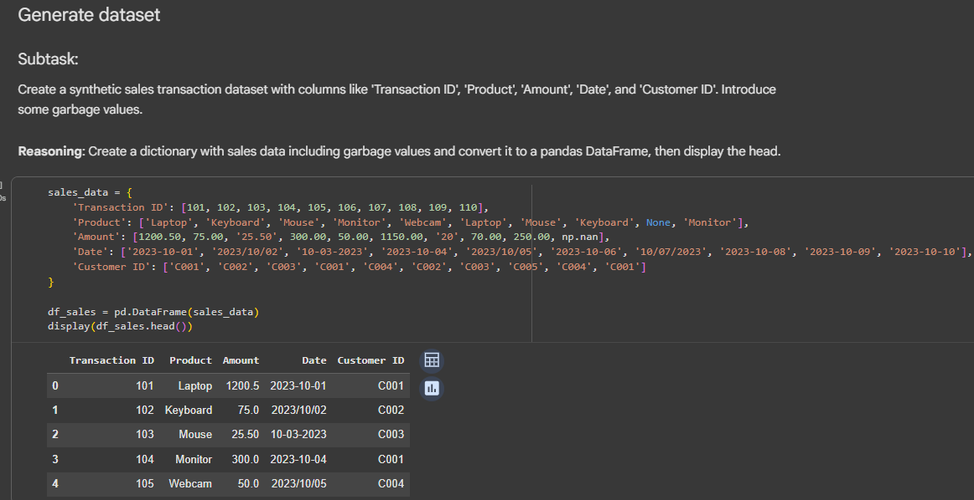
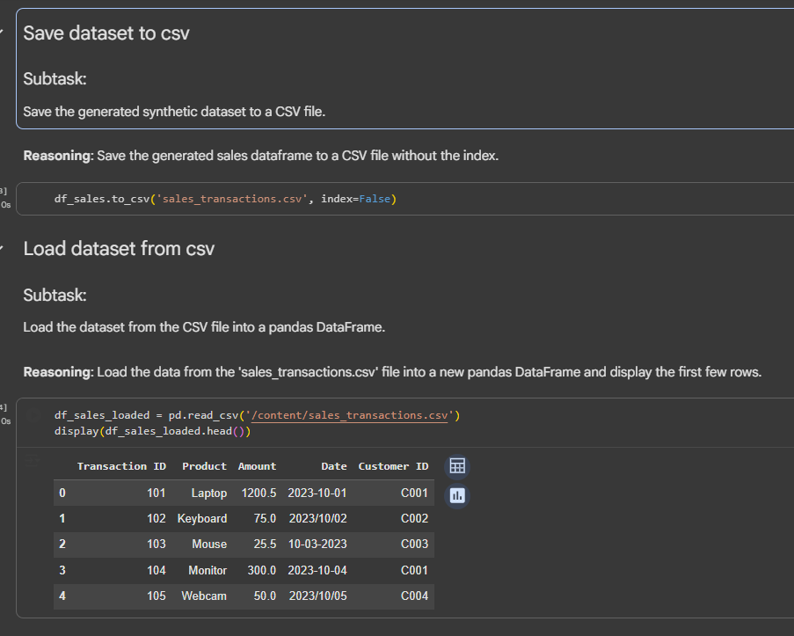
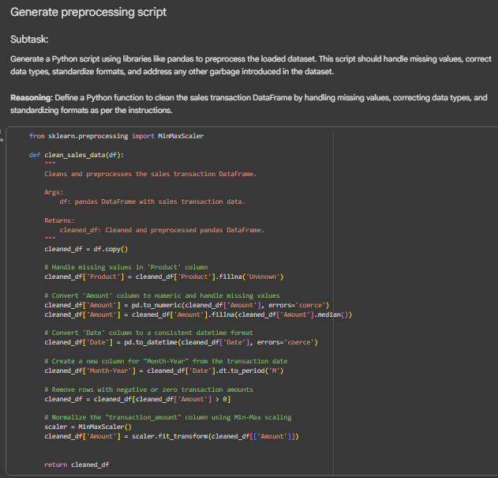
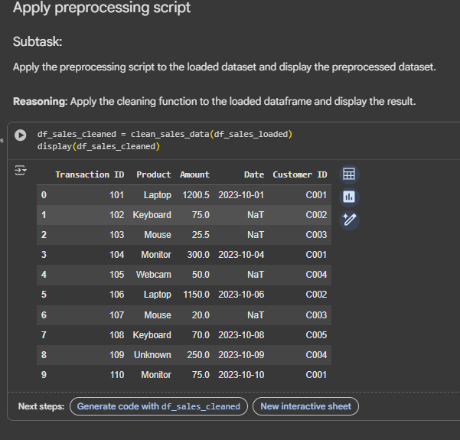

Task 3 – Healthcare Patient Records Cleaning
Task:
Use AI to generate a script for cleaning healthcare patient records.
Instructions:
• Fill missing values in numeric columns (e.g., blood_pressure,
heart_rate) with column mean.
• Standardize units (convert height from cm to meters).
• Correct inconsistent categorical labels (e.g., "M", "Male", "male"
→ "Male").
• Drop irrelevant columns such as patient_id after cleaning.
Expected Output:
• A cleaned healthcare dataset suitable for ML model training

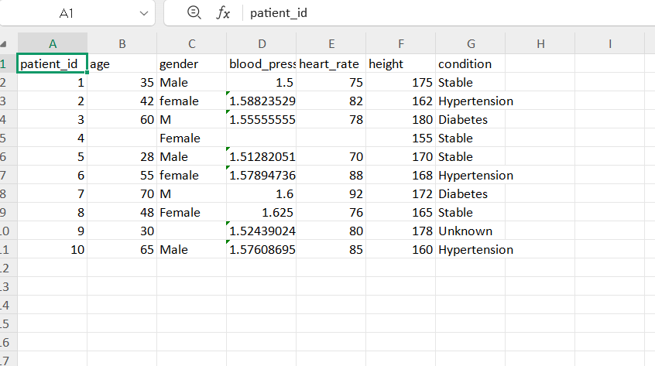
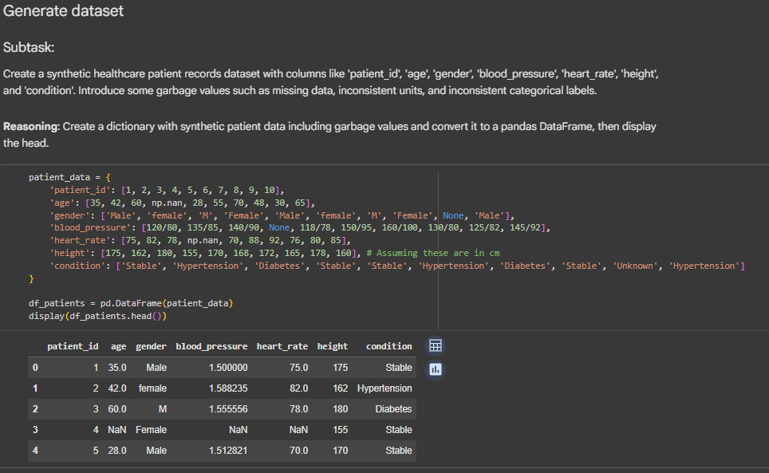
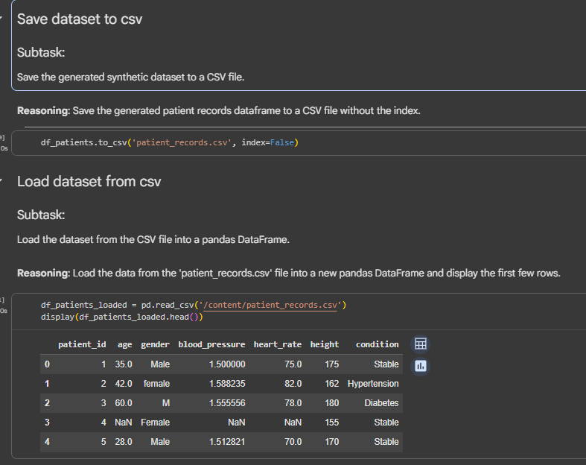
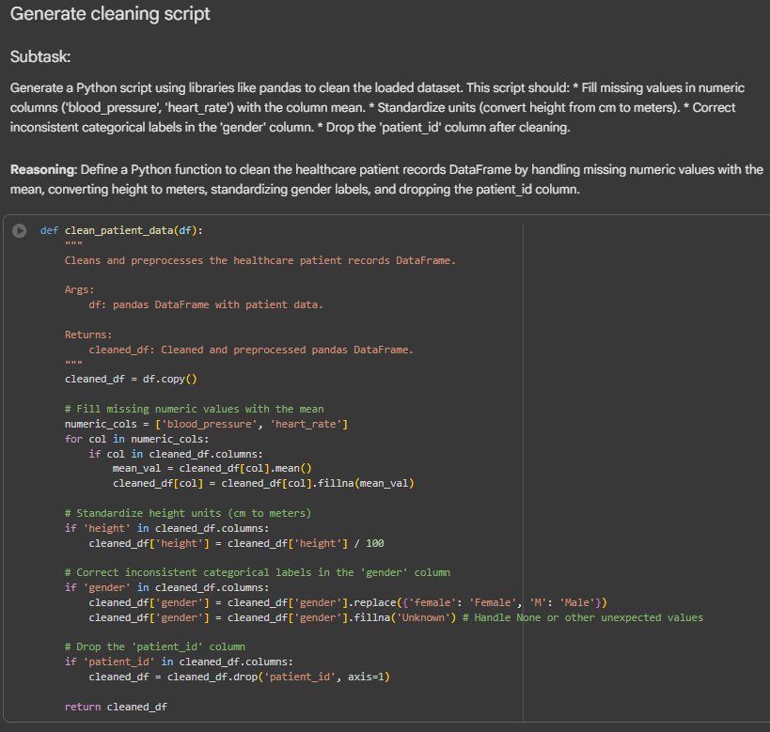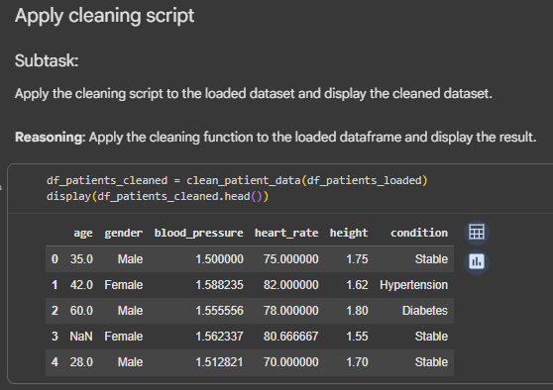
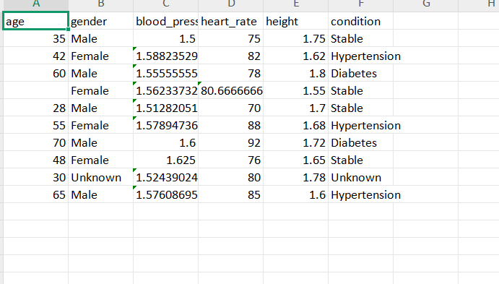

Task 4 – Social Media Sentiment Dataset Preparation
Task:
Use AI to write a script to preprocess a social media text dataset.
Instructions:
• Remove special characters, URLs, and emojis from text.
• Convert all text to lowercase.
• Tokenize and remove stopwords.
• Apply lemmatization for standardizing words.
Expected Output:
• A processed dataset with clean text, ready for NLP sentiment
analysis

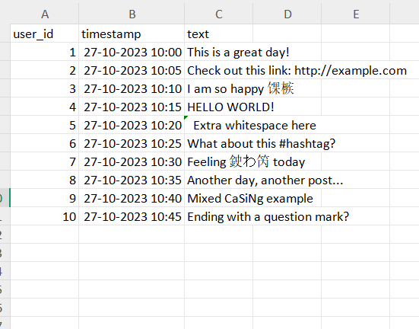

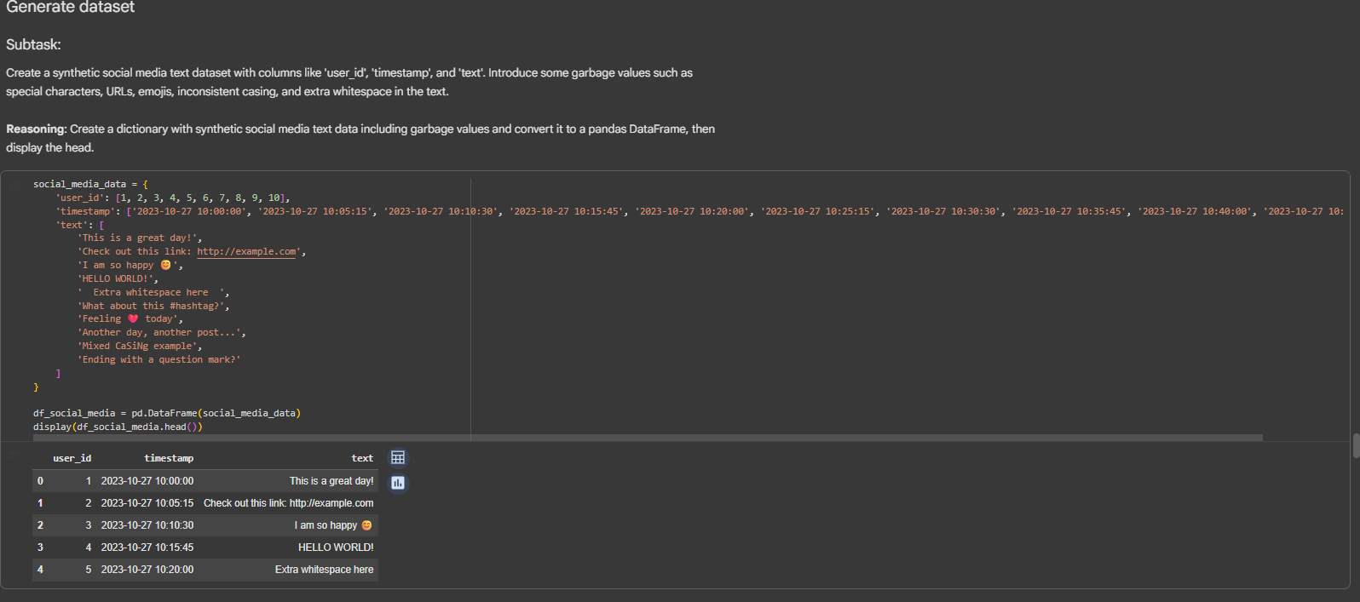
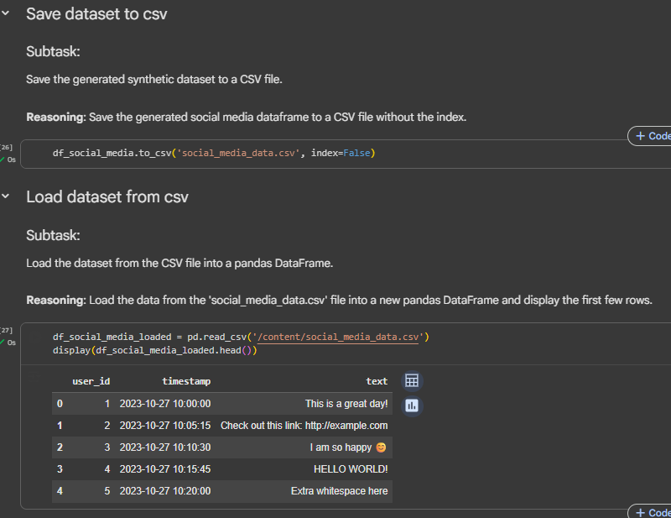
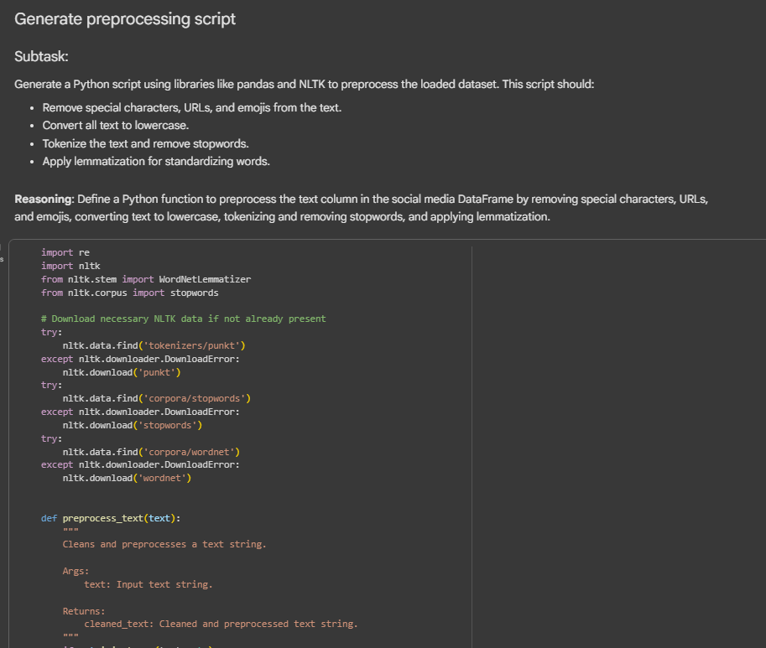
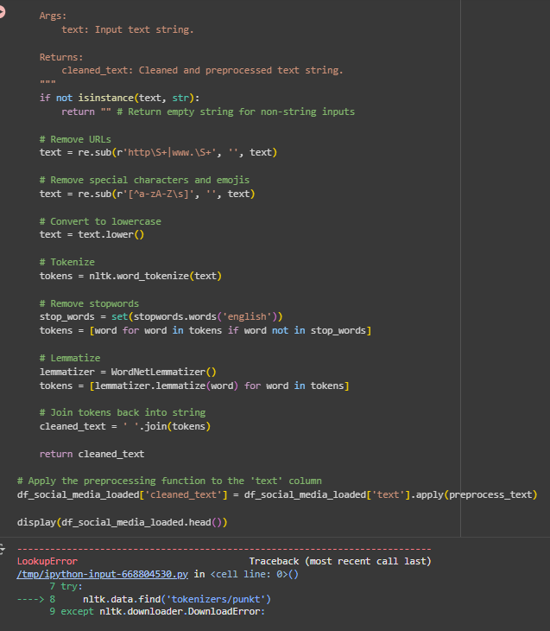
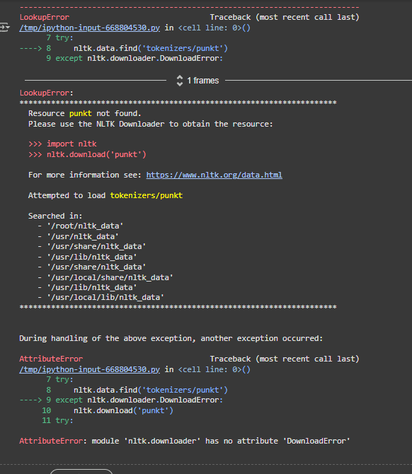
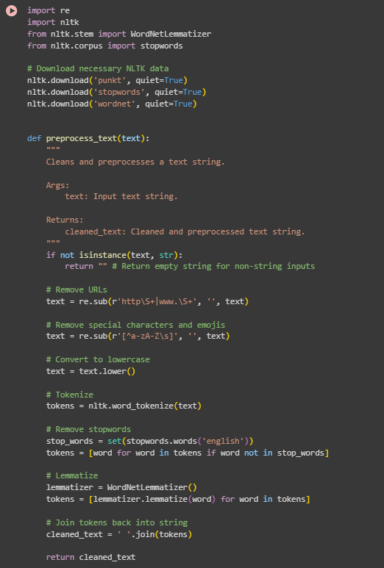
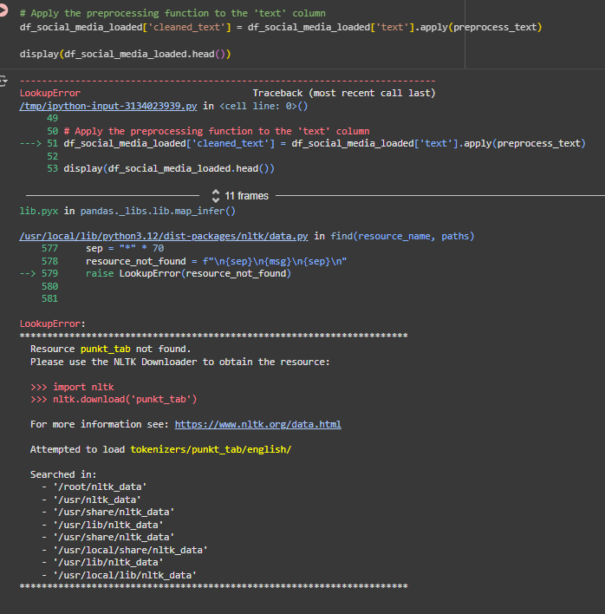
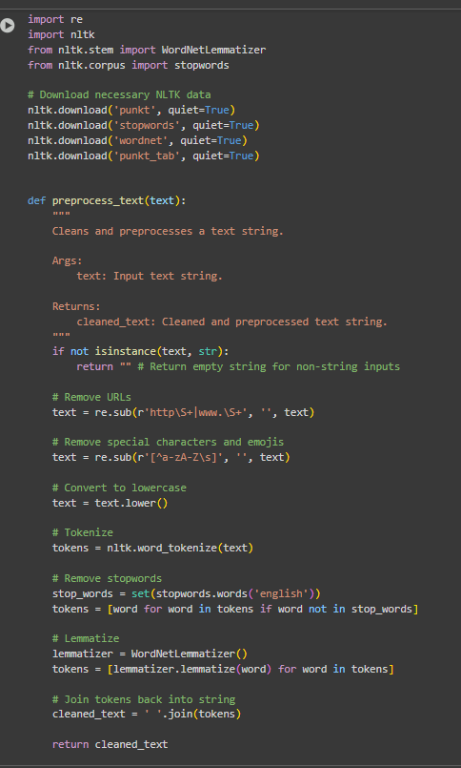
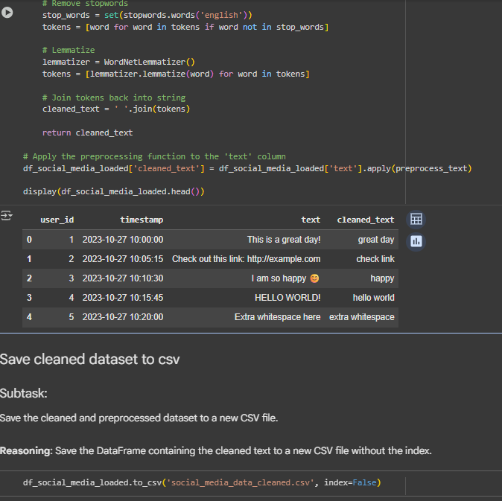
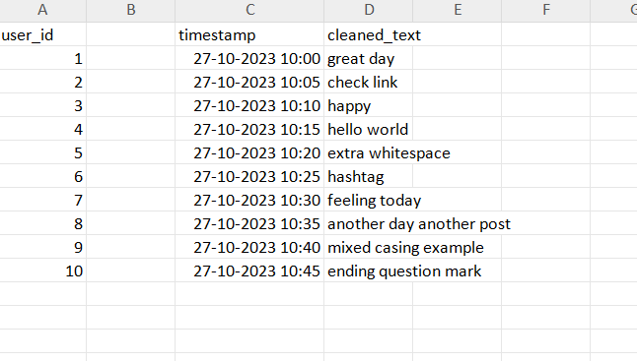

Task 5 – Financial Dataset Feature Engineering
Task:
Use AI to create a preprocessing script for a financial dataset.
Instructions:
• Handle missing values in stock price and volume.
• Create new features such as moving average (7-day, 30-day).
• Normalize continuous variables using StandardScaler.
• Encode categorical columns (sector, company_name).
Expected Output:
• A feature-engineered DataFrame with new indicators and
normalized values for ML tasks.

